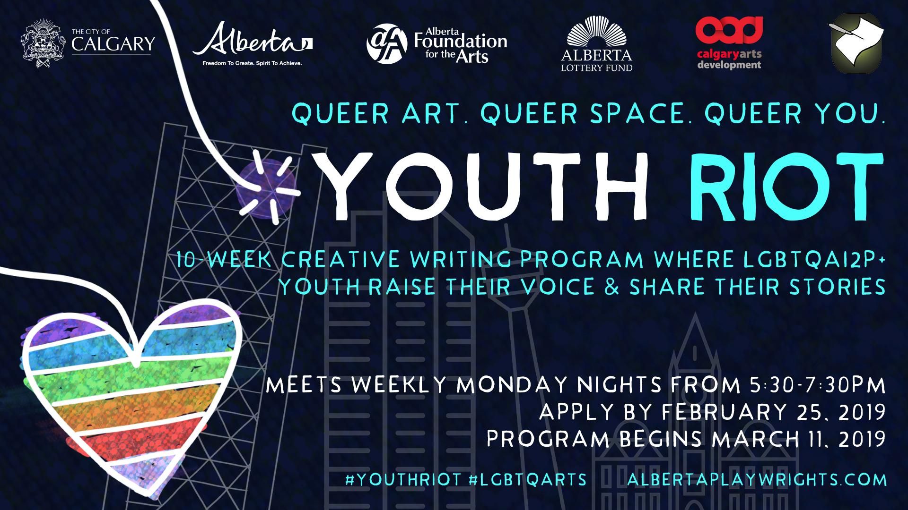
Queer art. Queer space. Queer you.
Alberta Playwrights’ Network’s YOUth Riot – now in its fifth year – is a FREE opportunity for Calgary’s Queer youth to raise their voice and share their stories!
Over the course of 10 weeks, Alberta Playwrights’ Network and guest artists will facilitate a creative writing program for Queer youth, helping them learn skills, meet other queer youth, create, imagine, inspire. This is YOUth Riot.
YOUth Riot finishes with a public festival of short pieces created by the participants by and staged by professional actors and directors from the theatre community.
We want to hear your story.
- 14 - 21 year olds across Calgary are encouraged to apply for this free 10-week program where you will learn tools and skills from professionals in the Calgary arts community to help develop your own story and voice.
Here are the details:
- Participation in YOUth Riot is 100% free to you.
- Absolutely no previous experience necessary.
- You must be between the ages of 14 to 21 years old to apply.
- YOUth Riot runs every Monday @ 5:30-7:30 pm | March 11 – May 13 2019
- All meetings are at Central Public Library, 800 3rd Street SE.
- All art created in the program will be featured in a public showcase Monday, May 20th 2019 at 7pm at Lunchbox Theatre at the base of the Calgary Tower.
- All you need to do is complete the application packet and email or scan it to: Courtney Tromburg, YOUth Riot Program Coordinator: courtney.tromburg@gmail.com

Application deadline is Sunday, February 25th, 2019 @ Midnight!
All we need is YOU.
Application Form
Name:
Birthday:
Home Address:
Phone Number:
Email:
Postal Code:
Pronoun Preference (if any):
Dietary restrictions (if any):
Medical conditions (if any):
Is there anything you would like us to know about you?

By signing this application, the applicant affirms that all above information is true and accurate:

______________________________________ _______________
(Signature of Applicant) (Date: DD/MM/YY)

Go to the next page to complete the application.

STATEMENT OF INTEREST [300-500 words]
Why do YOU want to participate in YOUth Riot?

