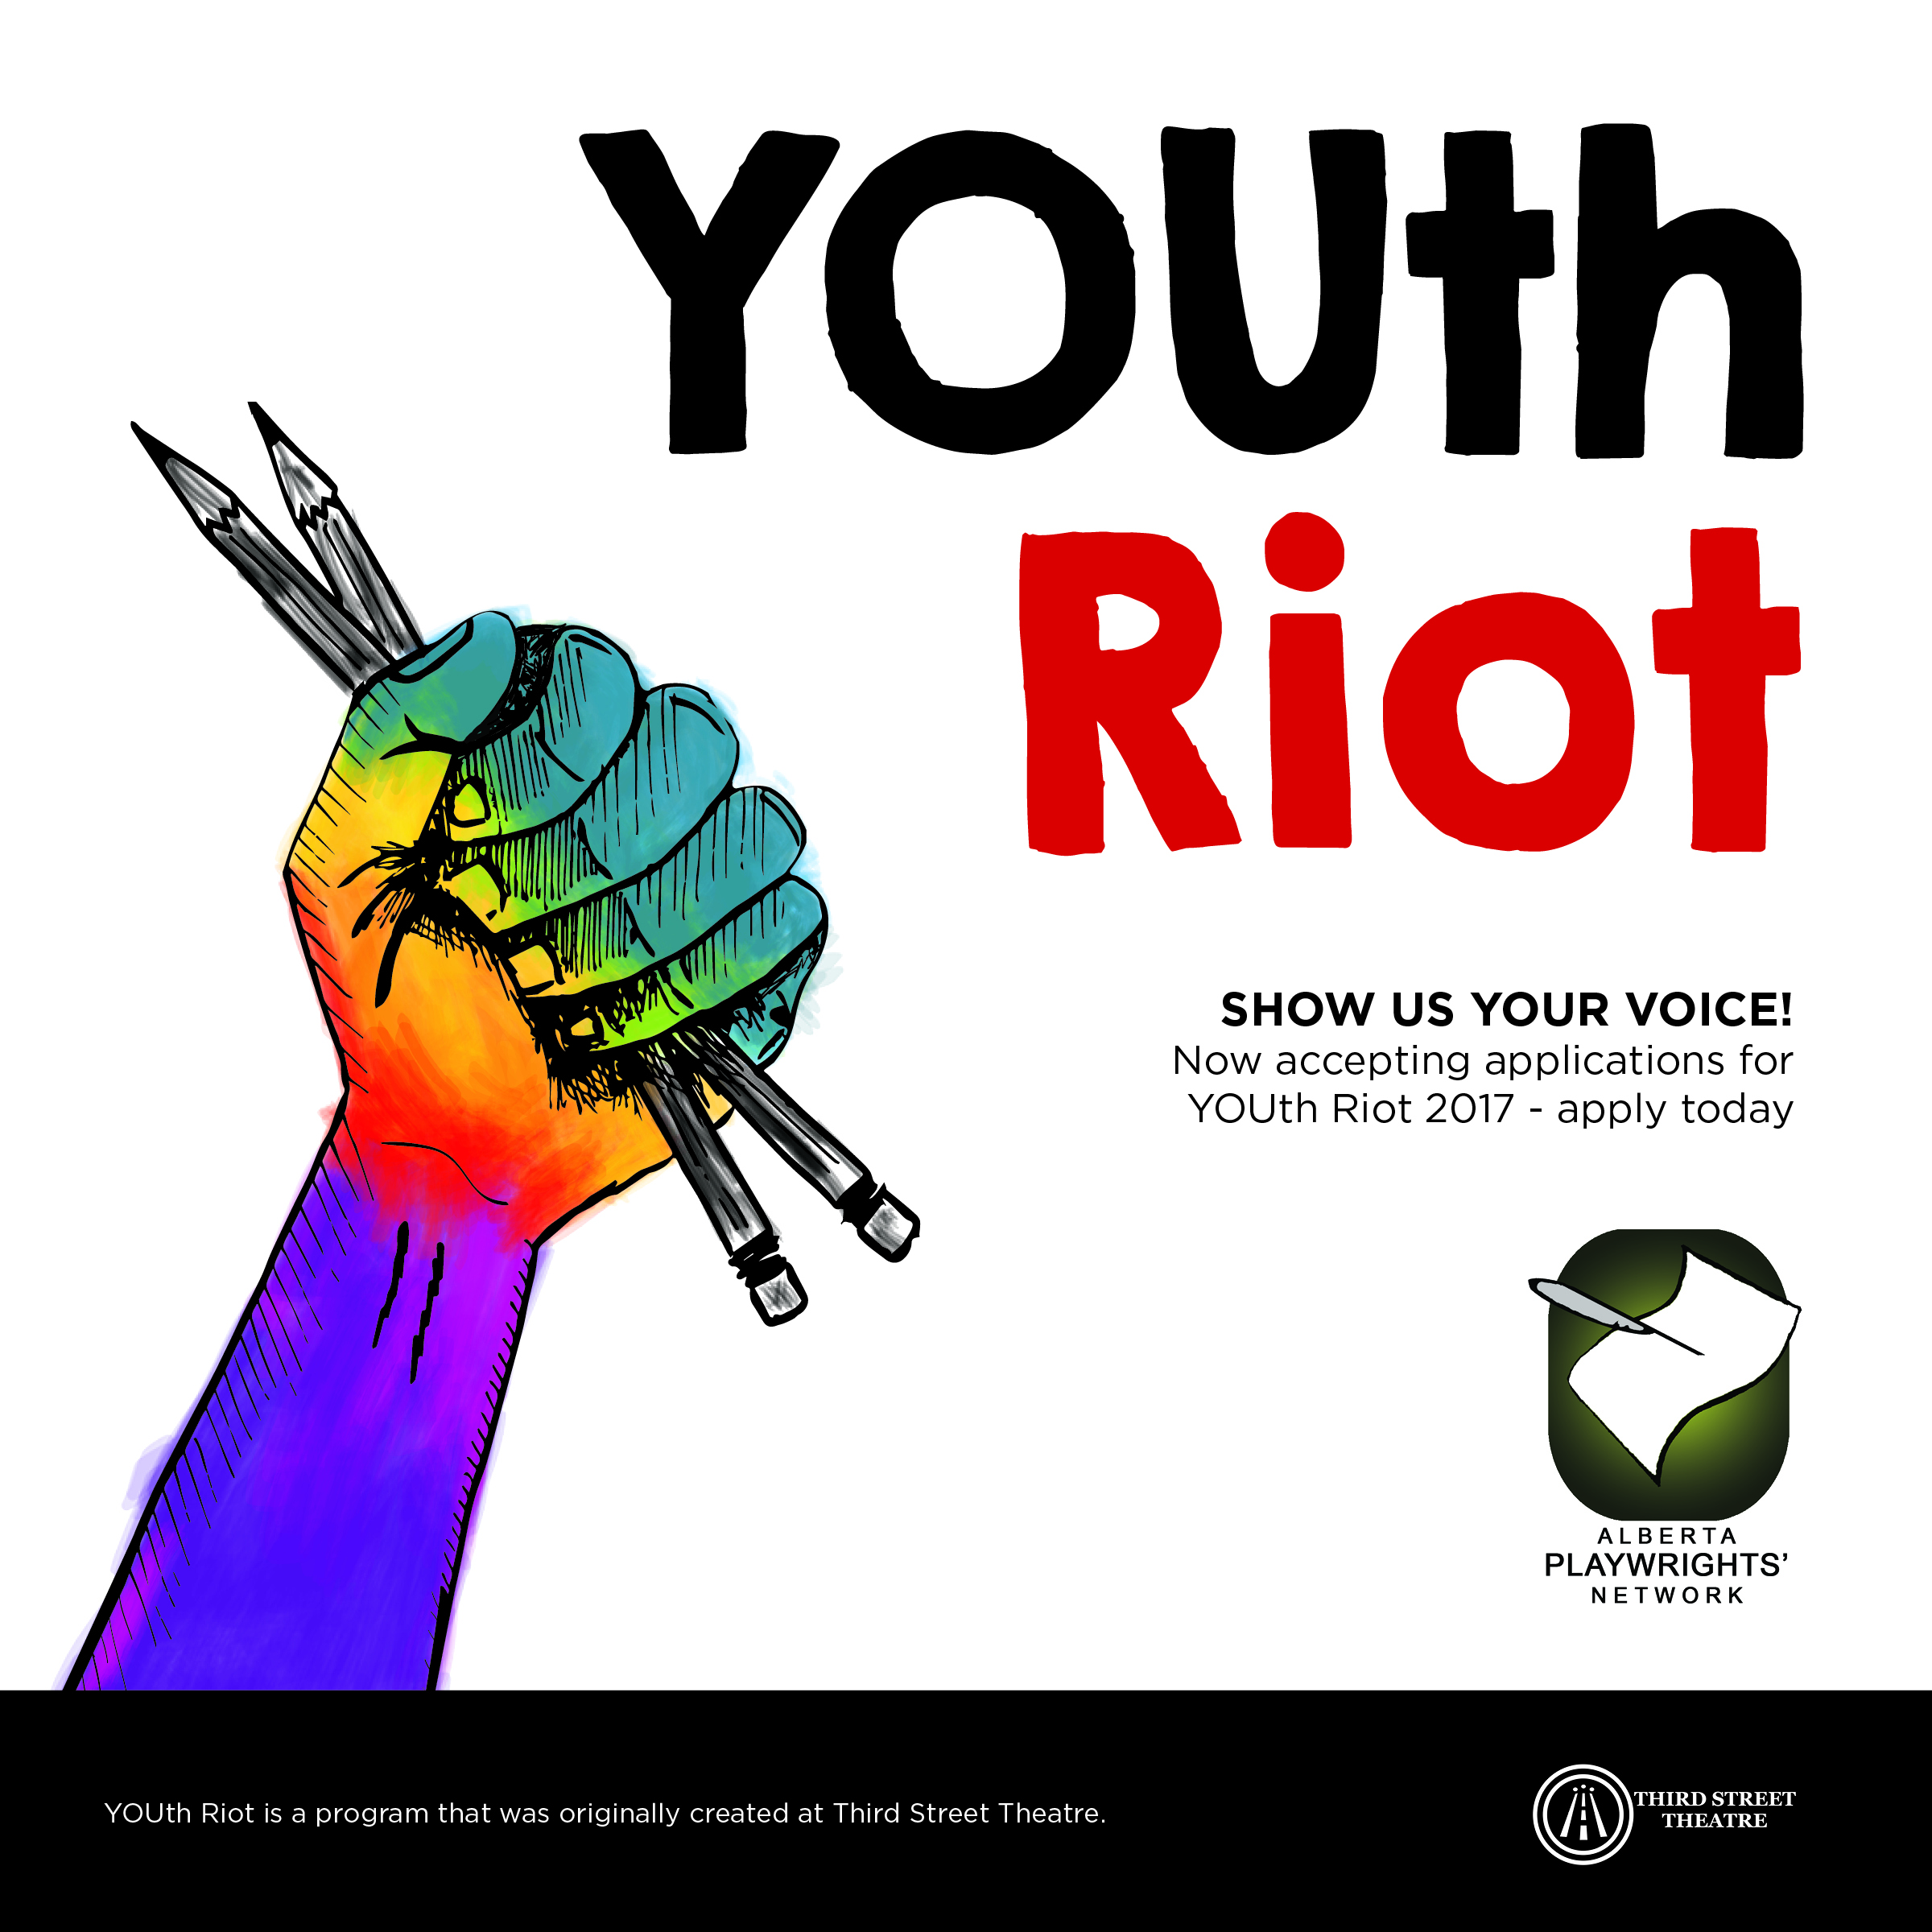
- Do you identify within the LGBTQQAIP2S+ spectrum?

- Are you between the ages of 13-20 years old?

- Do you want to create art with like-minded teens from across the city?

- Are you interested in learning creative ways to share your story?

- Do you want to learn from some of the best theatre artists in Calgary?
Then WE WANT YOU for YOUth Riot!
Alberta Playwrights’ Network’s YOUth Riot – now in its third year – is a FREE opportunity for Calgary’s Queer youth to rise against the status quo and learn to share their voices through the art of theatre!
Over the course of 3 months, Alberta Playwrights’ Network and guest artists will facilitate a writing program for Queer teens, helping them tell their stories through the medium of playwriting and theatre. Designed to ignite creativity in teens, YOUth Riot provides valuable tools to foster confidence, acceptance, and positive self-image through workshops, mentorship, and skill-building sessions.
YOUth Riot finishes with a public festival of short plays written by the participants and staged by professional actors and directors from the theatre community.
We want to hear your story because we believe that every story deserves to be heard!
- Teens across Calgary are encouraged to apply for this free 3-month program where you will learn tools and skills from professionals in the Calgary arts community to help develop your own short play, monologue, solo-show, or spoken-word poem… the possibilities are endless!
Here are the details:
- Participation in YOUth Riot is 100% free to you.
- Absolutely no experience necessary.
- You must be between the ages of 13 to 20 years old to apply.
- YOUth Riot runs every Thursday @ 6:00-9:00 pm | Feb 16 – May 4 2017 (except for on March 30 for Spring Break)
- All meetings are at CommunityWise Resource Centre, 223 12th Ave SW.
- All art created in the program will be featured in a public showcase Monday, May 15th 2017 at 7pm at Lunchbox Theatre at the base of the Calgary Tower.
- All you need to do is complete the application packet and email or scan it to: Paul Welch, YOUth Riot Program Co-ordinator: pwelch@bell.net

Application deadline is Friday, February 3rd, 2017 @ Midnight!

All we need is YOU.
For more info about the program, visit www.albertaplaywrights.com

YOUth Riot Application Checklist:
[] Application Form (this page, information below)
[] Statement of Interest (500-1000 words explaining why you want to participate in YOUth Riot)
_________________________________________________________________
Application Form

Name:
Birthday:
Home Address:
Phone Number:
Email:
Postal Code:
Dietary restrictions (if any):
Medical conditions (if any):
Is there anything you would like us to know about you?

By signing this application, the applicant affirms that all above information is true and accurate:

______________________________________ _______________
(Signature of Applicant) (Date: DD/MM/YY)

STATEMENT OF INTEREST [500-1,000 words]
Why do YOU want to participate in YOUth Riot?

