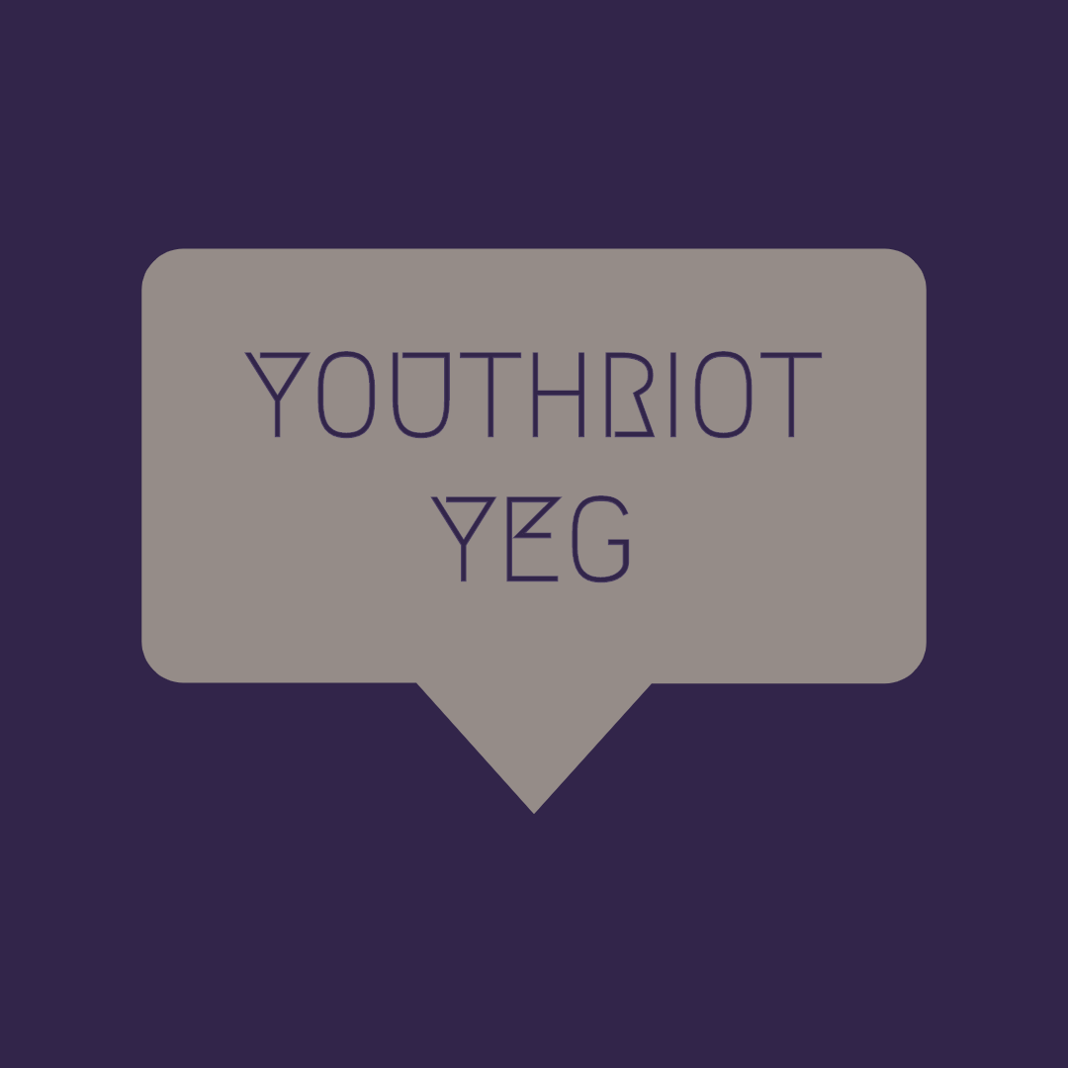
YOUTHRIOT YEG

What is YouthRiot YEG?

YouthRiot YEG is the sibling of Calgary's YOUth Riot program, originally conceived by Third Street Theatre and now administered by Alberta Playwrights' Network. It is a free, ten-week program for youth on the 2SLGBTQIA+ spectrum that teaches varied styles of creative writing for performance, in a safe environment where participants can learn, grow, and thrive.

Each week, a guest instructor will lead a workshop on a different style of writing for performance. The program culminates in a public presentation of work created by the participants over the ten weeks.

We are excited to launch the inaugural year of the program here in Edmonton, and are looking for curious, enthusiastic participants with a strong desire to explore different forms of writing and creation. Does this sound like a fit for you?

Here are the details:

*Participation in YouthRiot YEG is 100% free for the participants

*Absolutely no previous experience is necessary

*You must be between the ages of 15 to 20 years old to apply

*YouthRiot YEG runs every Wednesday from 6:30 to 9:30 pm, October 2 to December 3, 2019

*Meetings will take place in the Old Strathcona area of Edmonton. Successful applicants will be contacted with more information upon acceptance to the program.

To apply, please complete this form and send it to bevin@albertaplaywrights.com.

Any questions? Send those to Bevin as well and she'll help you out!

Application deadline is Wednesday, September 25th, 2019 at 11:59 pm
Applicant Information
*= Required Information

Name*:

Date of Birth*:

Home Address*:

Email*:

Phone Number*:

Pronouns:

Dietary Restrictions:

Medical Conditions*:

Tell us five interesting things about yourself:

1.

2.

3.

4.

5.

Expression of Interest
*= Required Information

Why do you want participate in YouthRiot YEG? (500 words max)*

What kind of project would you like to work on at YouthRiot YEG? (500 words max)*

Reference name, contact information, and relation to applicant*:

